**PROJECT 1:**

Task 1: Create a windows instance using AMI: Windows 2012 R2 base

Ans: Windows 2012 is not showing free so created Windows 2016 instance

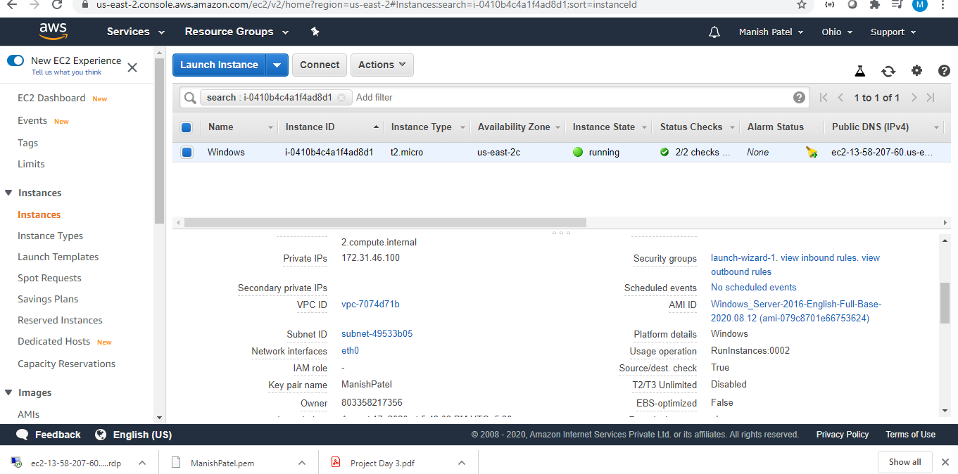

Task 2:Launch the Windows instance using RDP 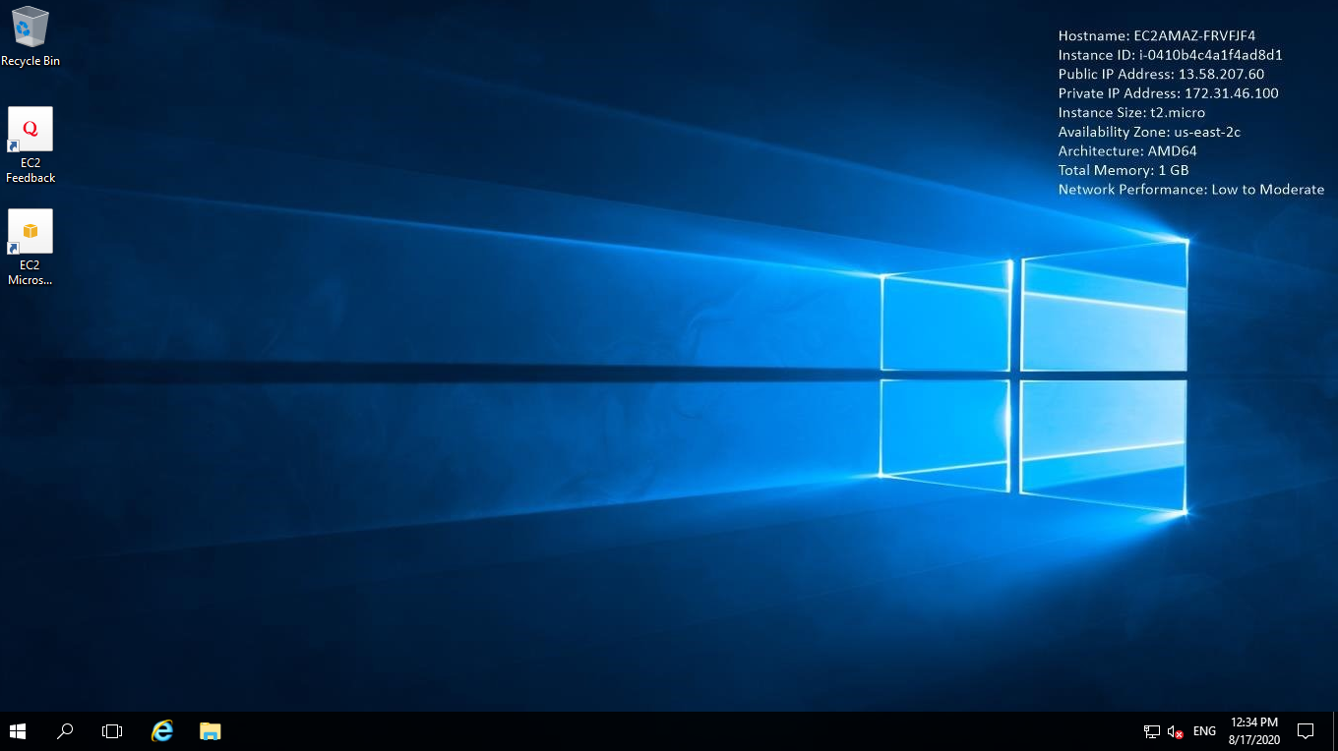

Task 3:Install IIS web server using Powershell ISE

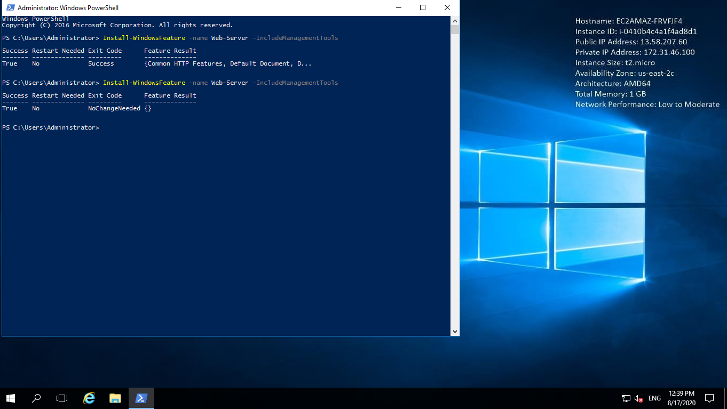

Task 4: Verify successful installation of IIS Web Server

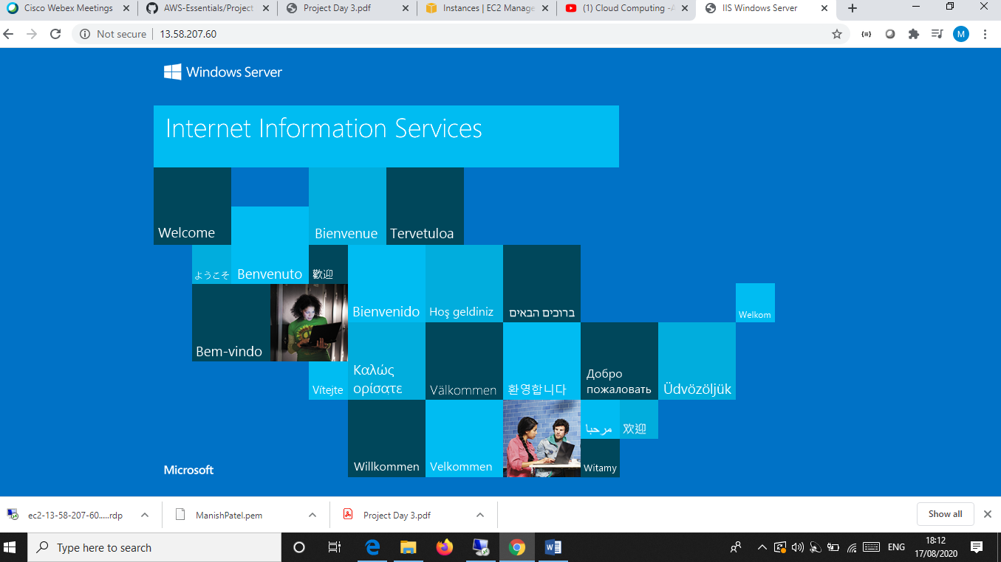

**PROJECT 2**

Task 1: Create a windows instance using AMI: Ubuntu Server 18.04 LTS (HVM)

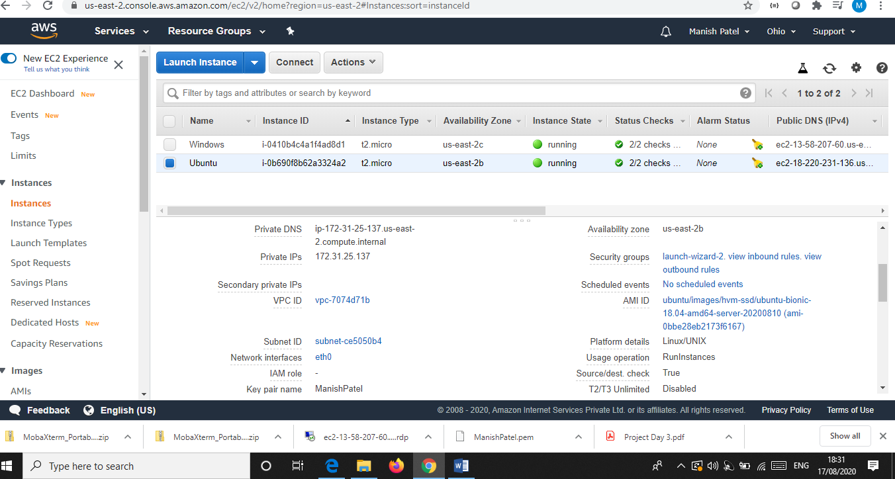

Task 2: Download and install MobaXterm Portable Edition

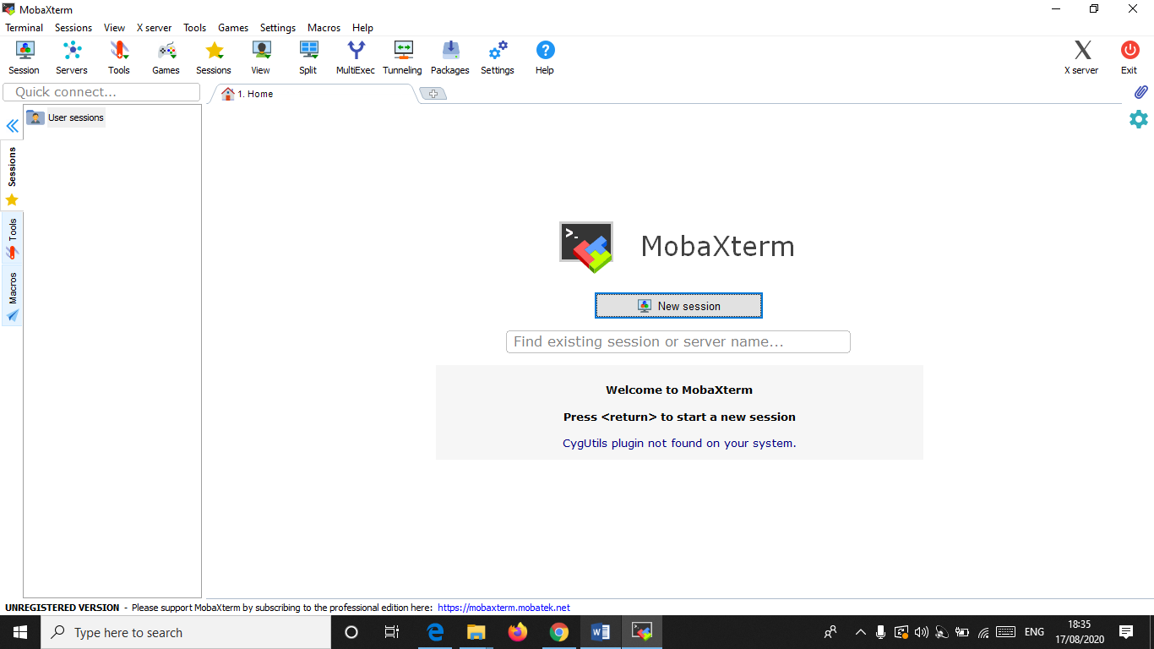

Task 2:Launch the Ubuntu instance using SSH

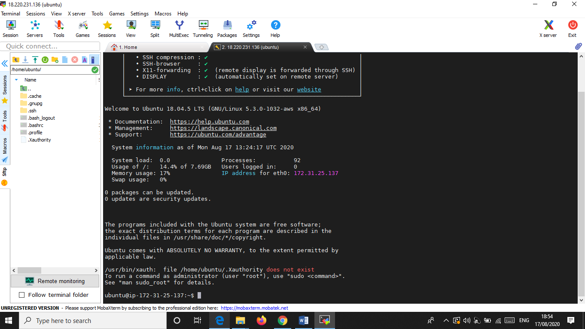

Task 3: Install ngnix web server using bash

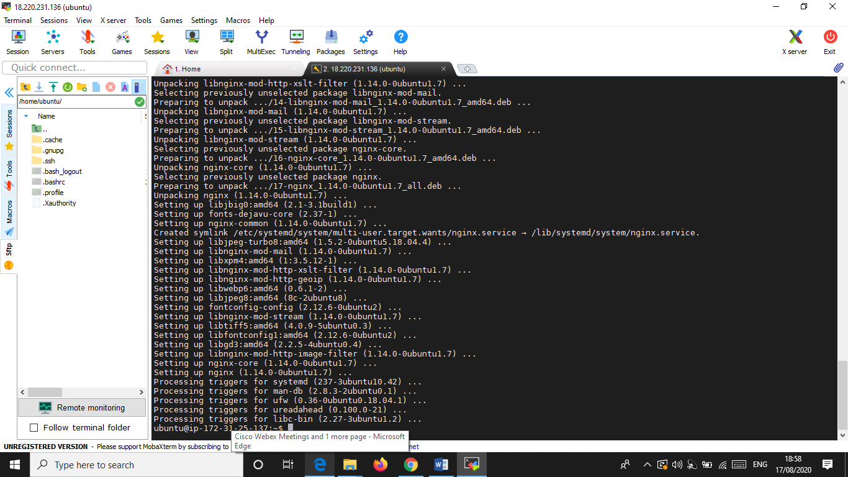

Task 4: Verify successful installation of ngnix

